Finding Missing Numbers - Questions

Key Stage 2: 2003 Paper A
1.
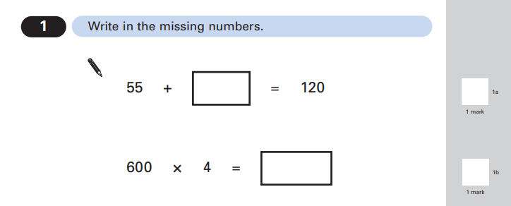

Key Stage 2: 2003 Paper A
2.

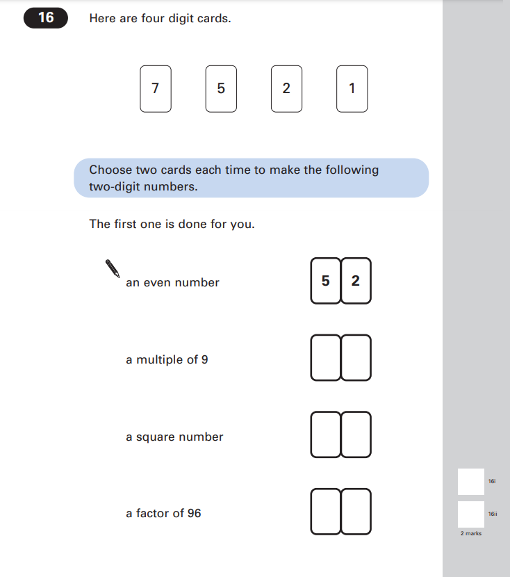

Key Stage 2: 2003 Paper A
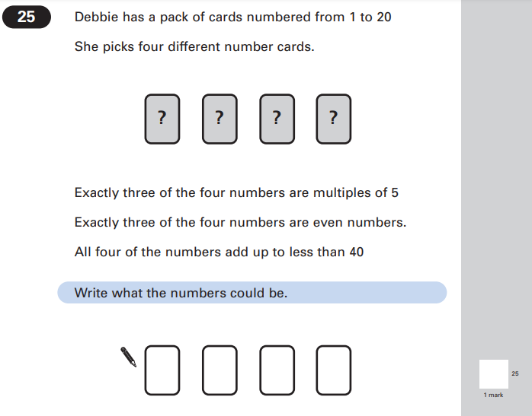
3.

Key Stage 2: 2003 Paper A
4.

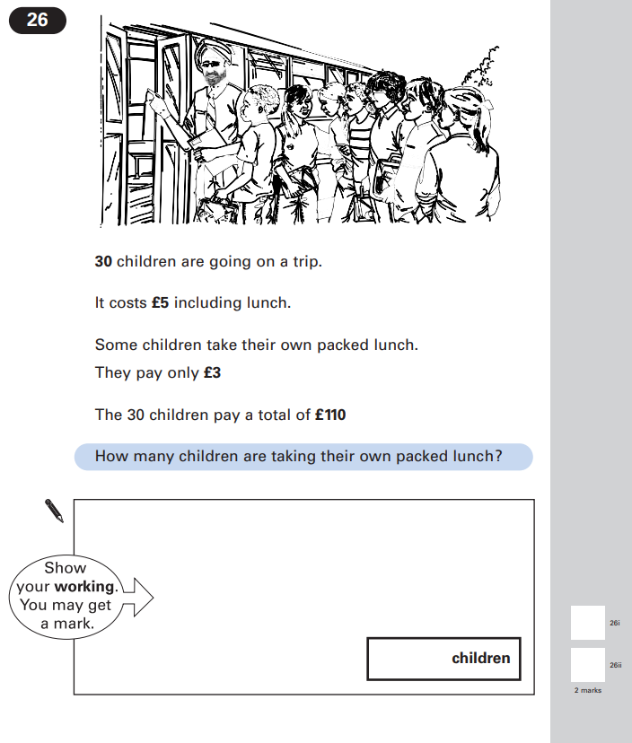

Key Stage 2: 2003 Paper B
1.
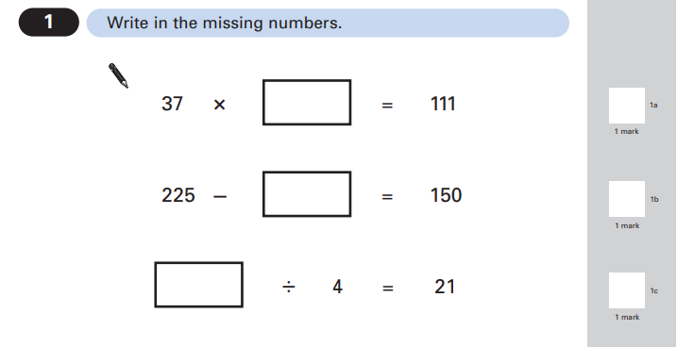

Key Stage 2: 2003 Paper B
2.

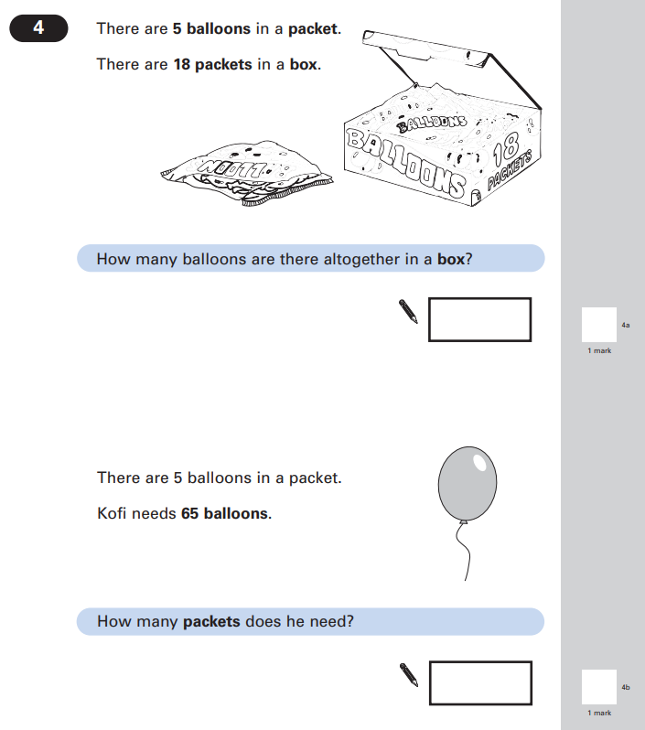

Key Stage 2: 2003 Paper B
3.
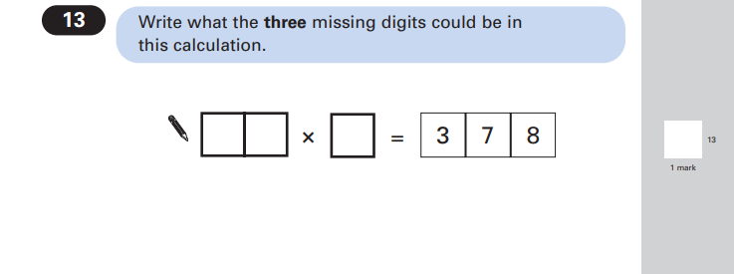
Key Stage 2: 2003 Paper B
4.
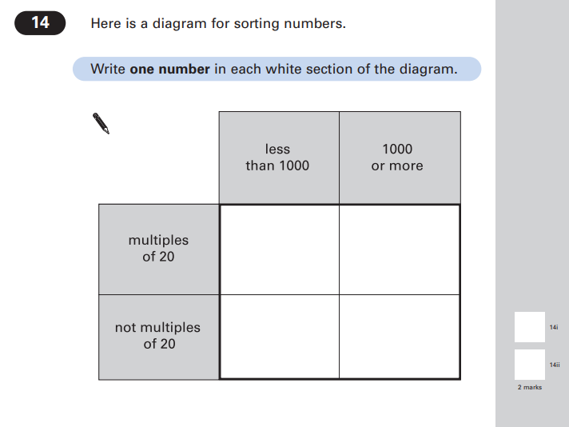

Key Stage 2: 2003 Paper B
5.
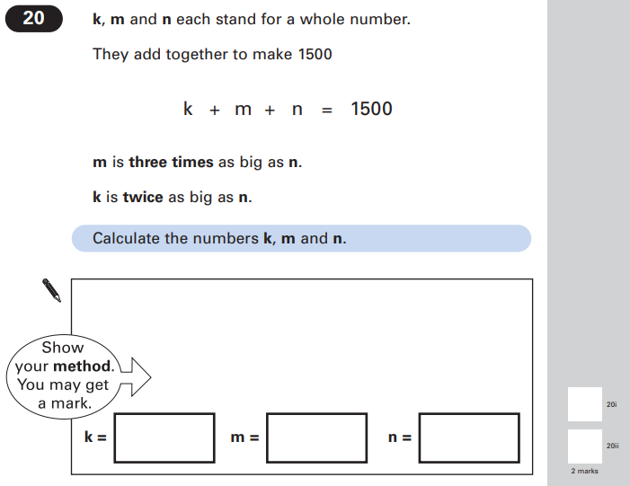

Key Stage 2: 2003 Paper B
6.
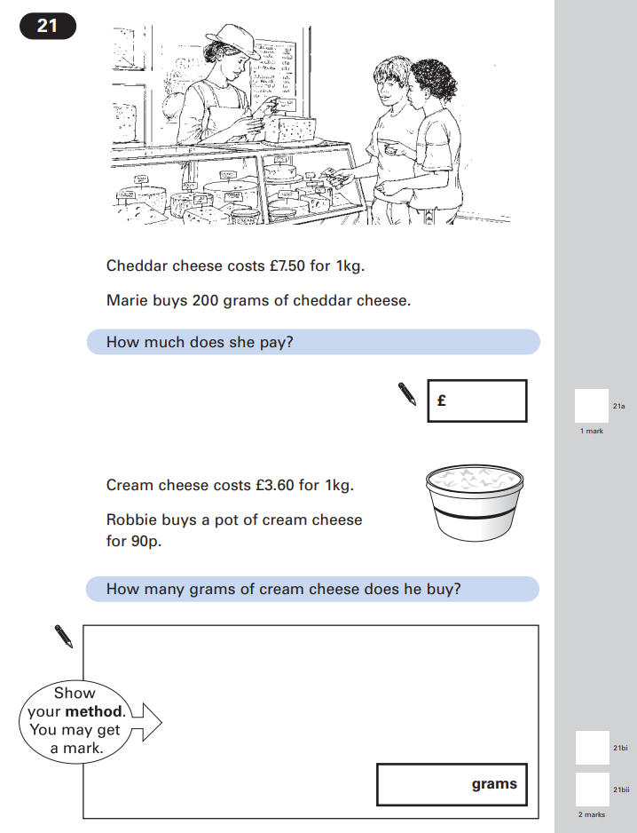

Key Stage 2: 2004 Paper A
1.
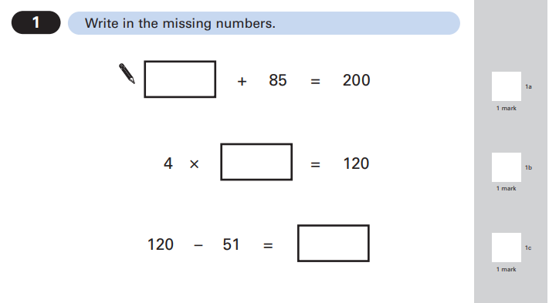

Key Stage 2: 2004 Paper A
2.
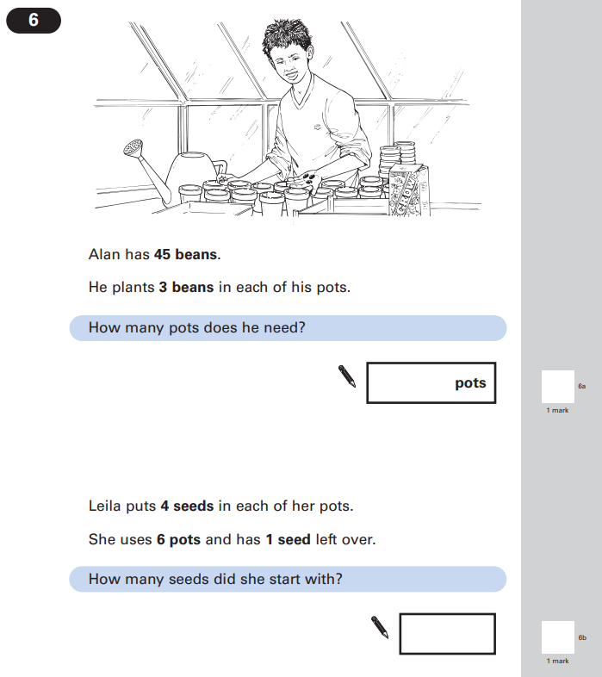

Key Stage 2: 2004 Paper A
3.
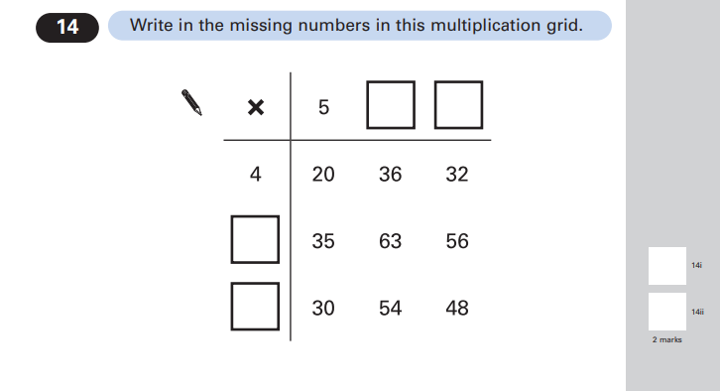
Key Stage 2: 2004 Paper B
1.
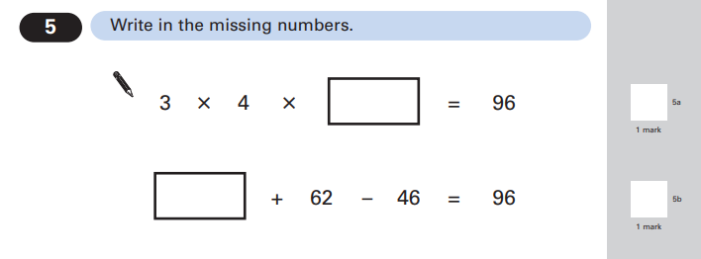

Key Stage 2: 2004 Paper B
2.
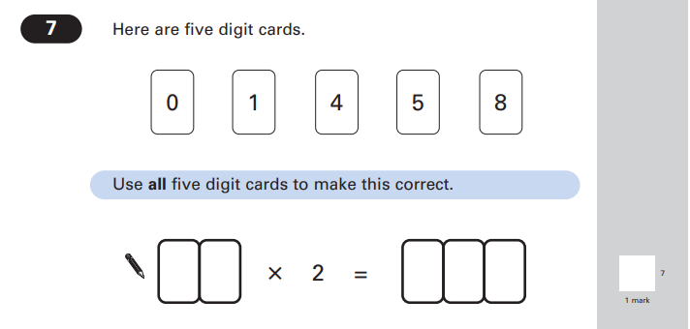
Key Stage 2: 2004 Paper B
3.
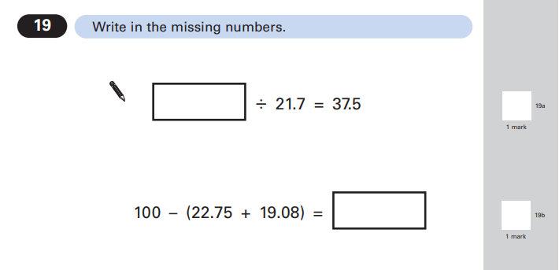

Key Stage 2: 2004 Paper B
4.
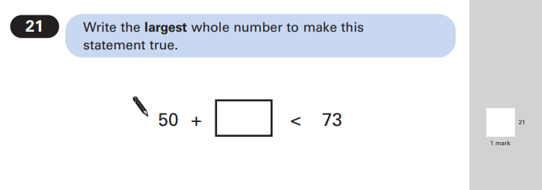

Key Stage 2: 2005 Paper A
1.
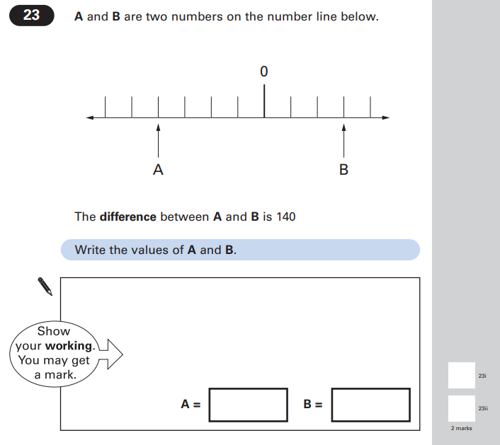

Key Stage 2: 2005 Paper B
1.
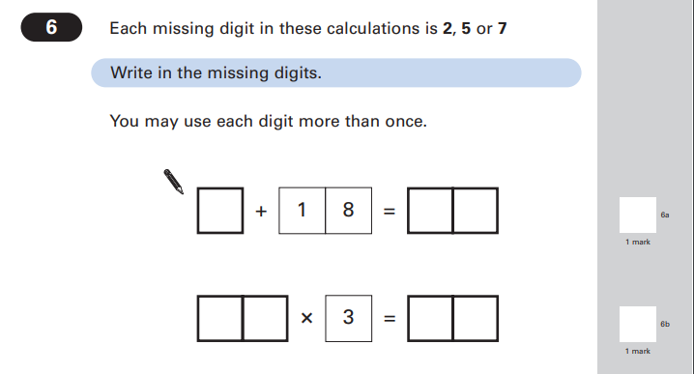

Key Stage 2: 2005 Paper B
2.
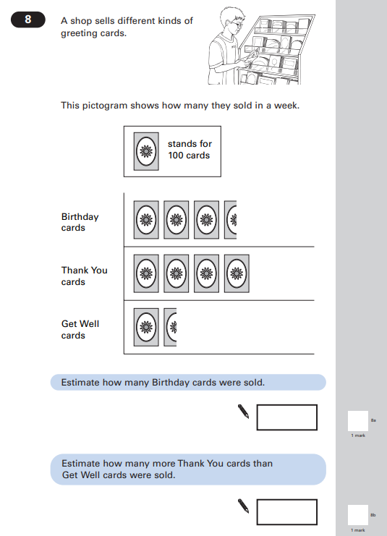

Key Stage 2: 2005 Paper B
3.
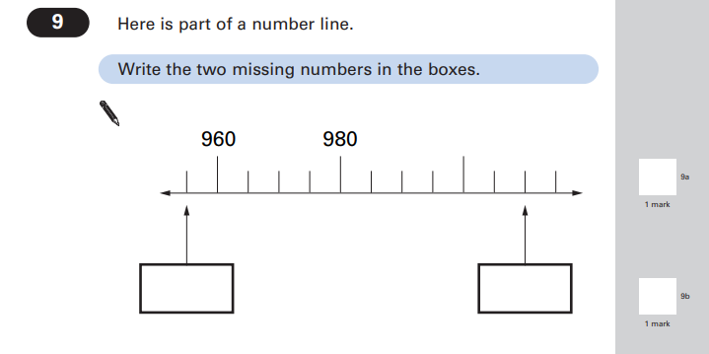
Key Stage 2: 2005 Paper B
4.
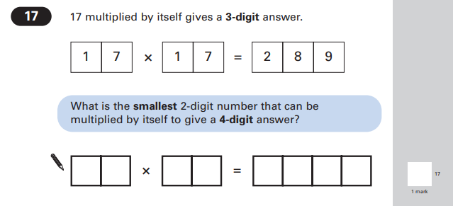

Key Stage 2: 2006 Paper B
1.
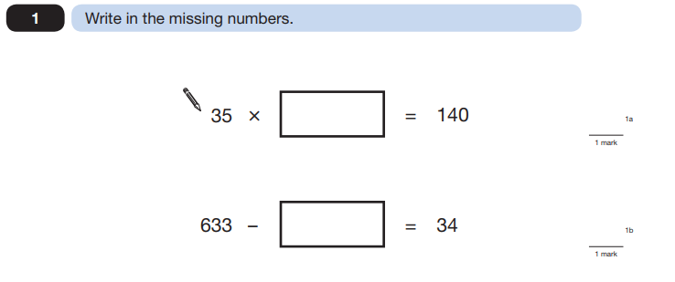
Key Stage 2: 2006 Paper B
2.
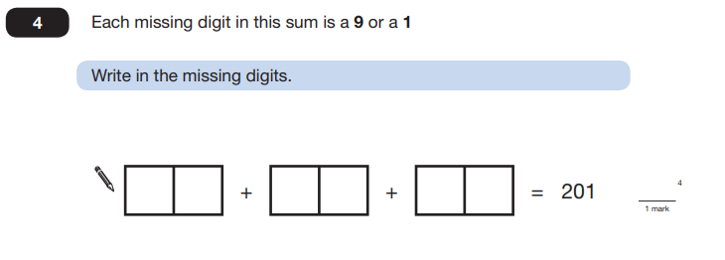

Key Stage 2: 2007 Paper A
1.
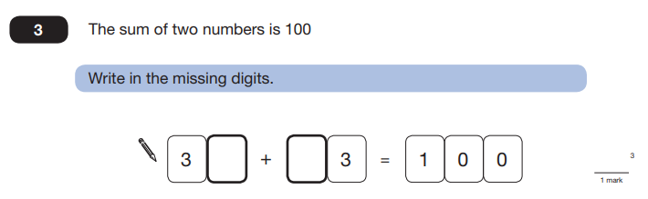
Key Stage 2: 2007 Paper B
1.
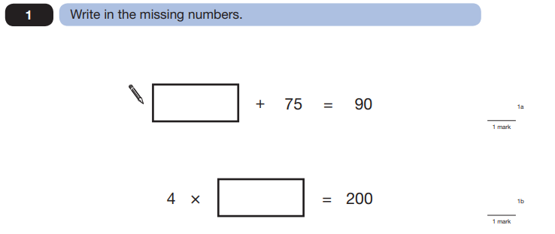

Key Stage 2: 2007 Paper B
2.
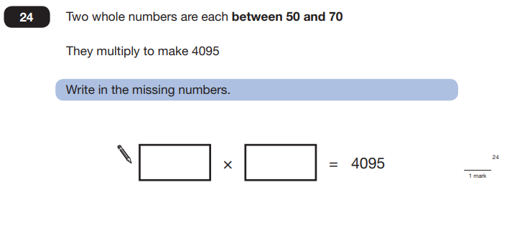
Key Stage 2: 2009 Paper B
1.
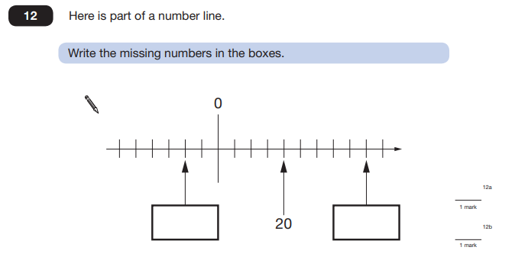

Key Stage 2: 2010 Paper A
1.
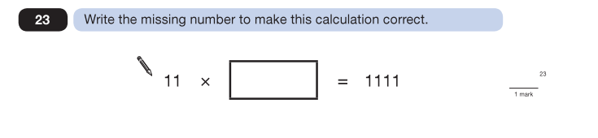
Key Stage 2: 2010 Paper B
1.
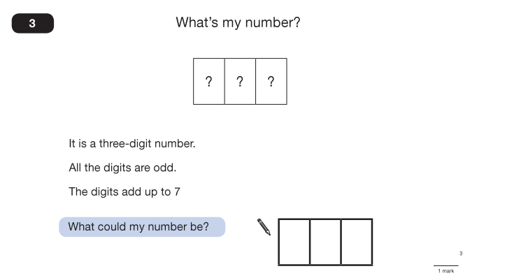

Key Stage 2: 2011 Paper A L6
1.
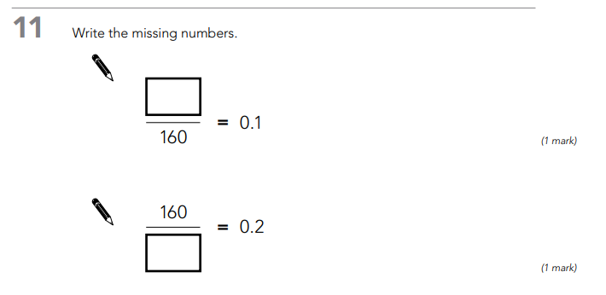

Key Stage 2: 2011 Paper B L6
1.
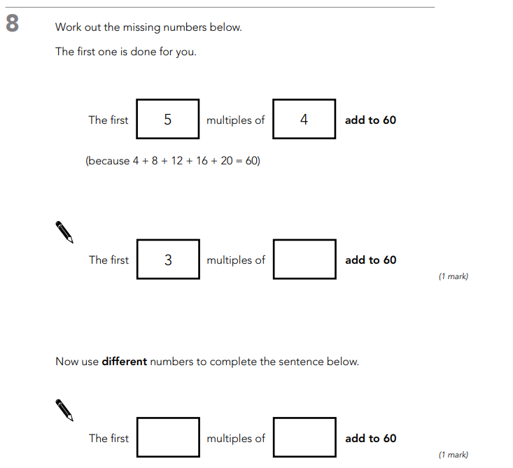

Key Stage 2: 2011 Paper B
1.
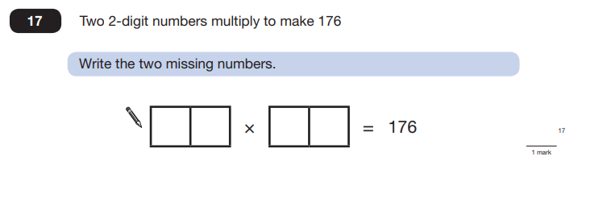
Key Stage 2: 2012 Paper B L6
1.
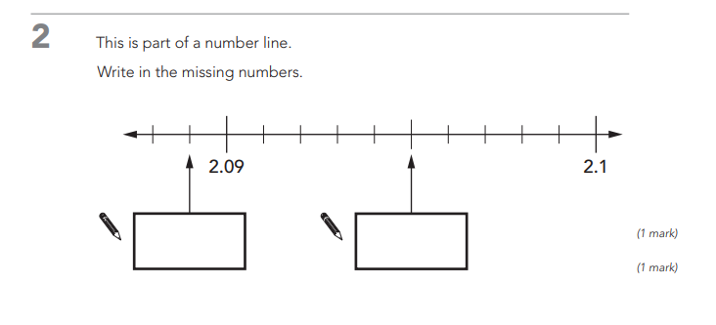

Key Stage 2: 2012 Paper A
1.
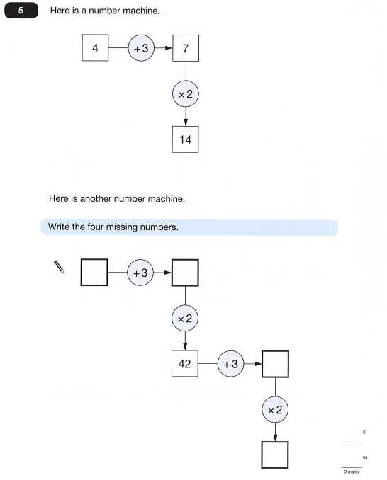

Key Stage 2: 2012 Paper B
1.
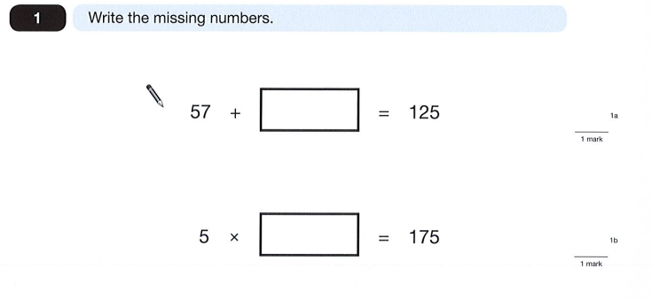

Key Stage 2: 2013 Paper A L6
1.
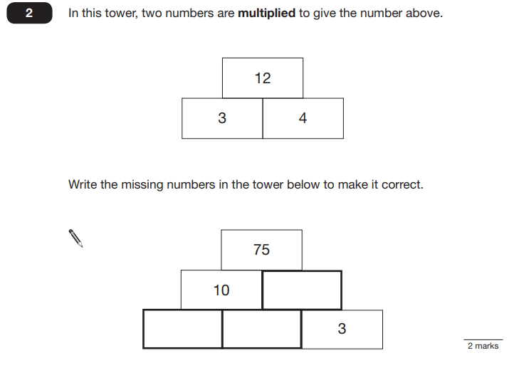

Key Stage 2: 2013 Paper B L6
1.
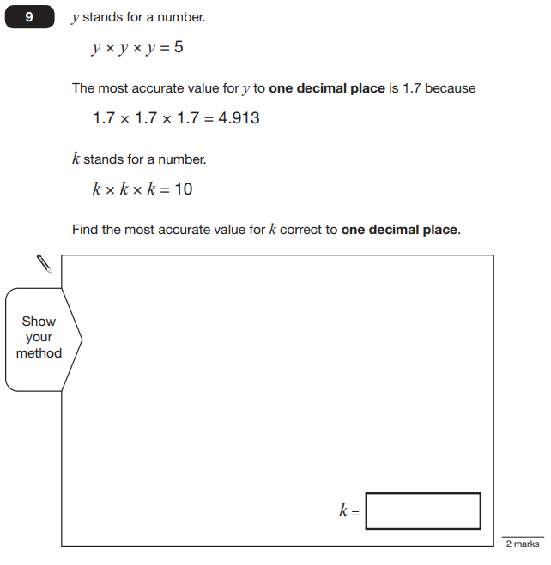

Key Stage 2: 2013 Paper A
1.
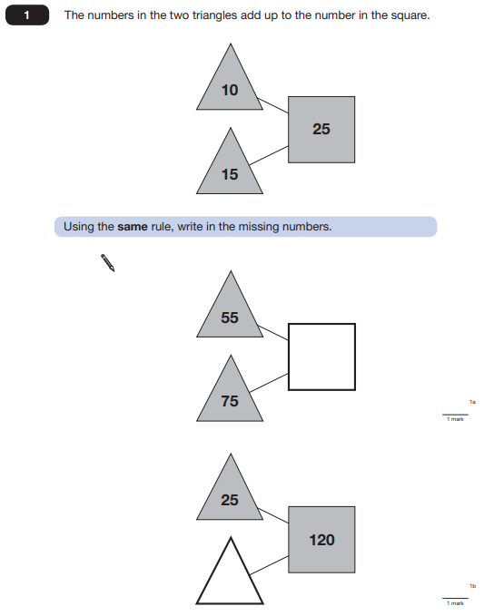

Key Stage 2: 2013 Paper B
1.
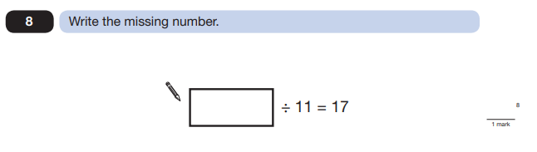
Key Stage 2: 2014 Paper A L6
1.
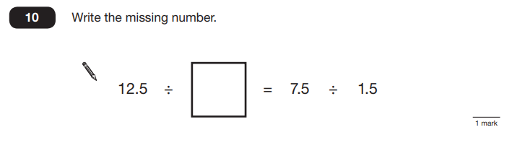
Key Stage 2: 2014 Paper B
1.
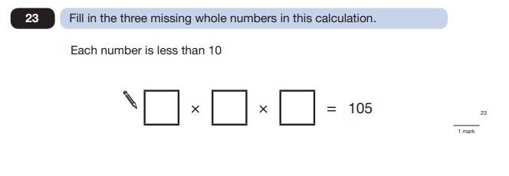

Key Stage 2: 2014 Paper A
1.
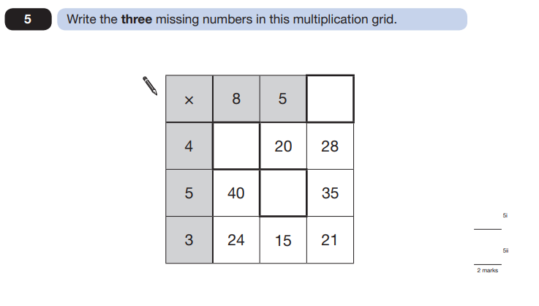

Key Stage 2: 2015 Paper A L6
1.
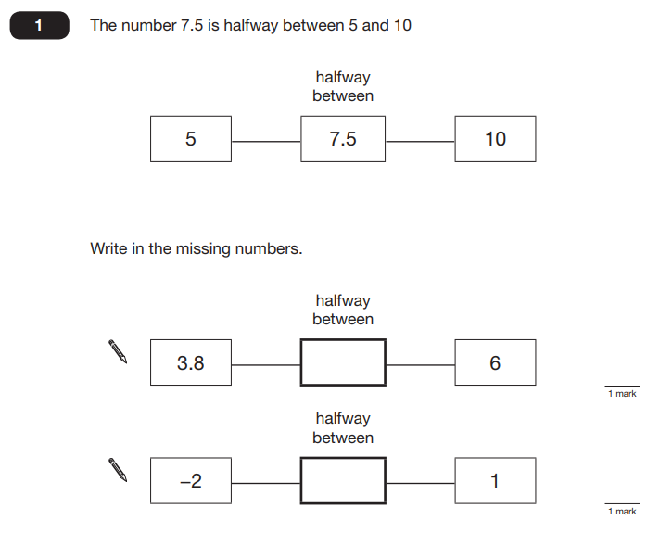

Key Stage 2: 2015 Paper A L6
2.
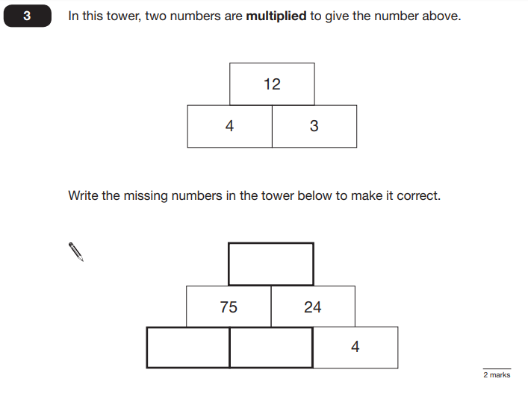

Key Stage 2: 2015 Paper A
1.
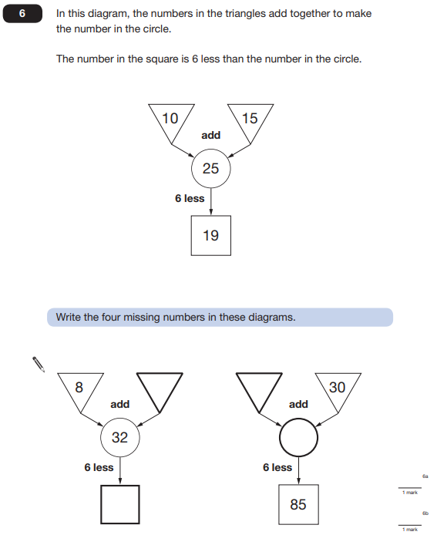

Key Stage 2: 2015 Paper A
2.
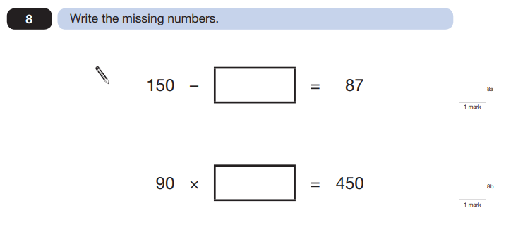

Key Stage 2: 2015 Paper A
3.
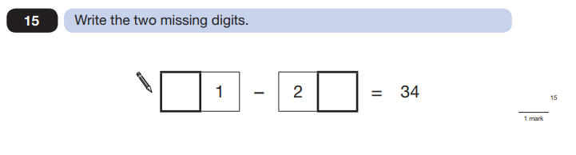

Key Stage 2: 2015 Paper A
4.
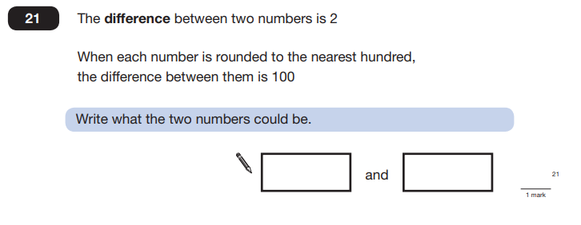
Key Stage 2: 2015 Paper B
1.
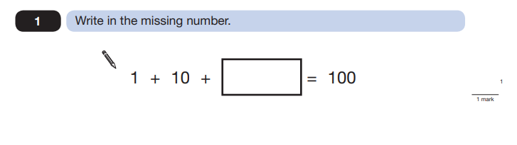
Key Stage 2: 2015 Paper B
2.
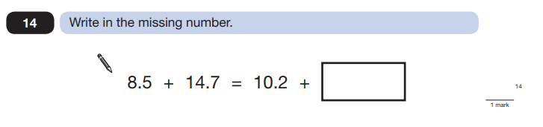

Key Stage 2: 2015 Paper B
3.
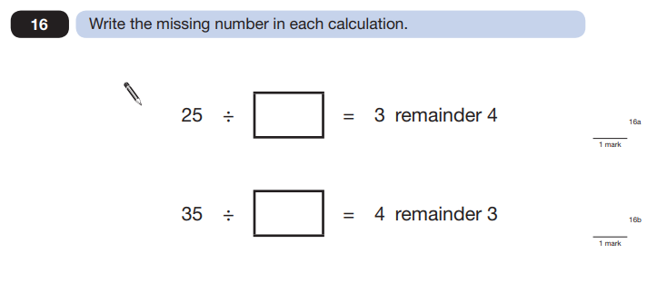
Key Stage 2: Paper 2 and 3 Reasoning - Sample
1.
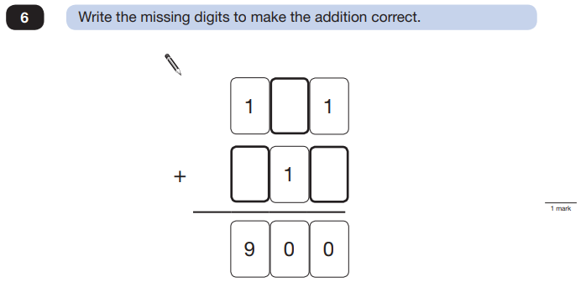

Key Stage 2: 2016 Paper 2 Reasoning - Sample
1.
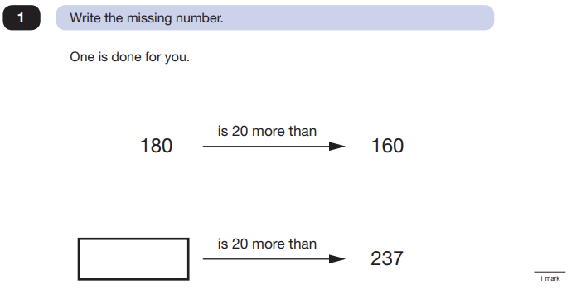

Key Stage 2: 2016 Paper 3 Reasoning - Sample
1.
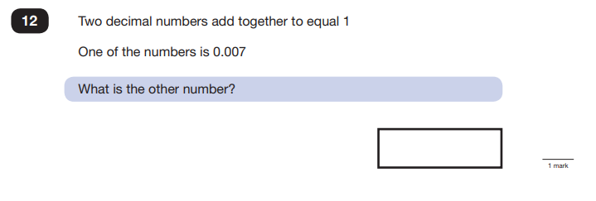

Key Stage 2: 2016 Paper 3 Reasoning - Sample
2.
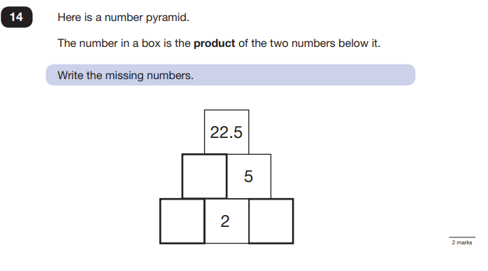

Key Stage 2: 2016 Paper 2 Reasoning
1.
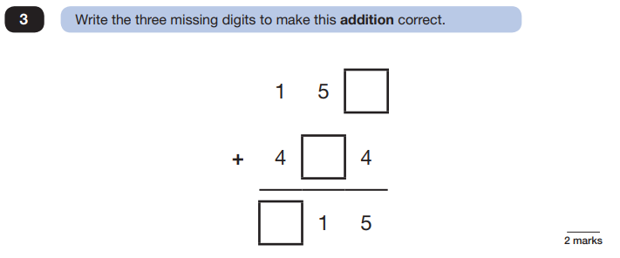

Key Stage 2: 2016 Paper 2 Reasoning
2.
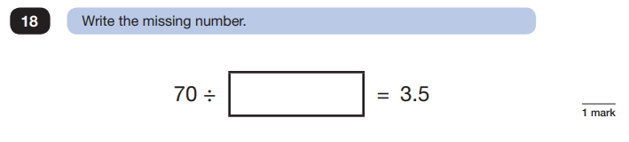
Key Stage 2: 2018 Paper 3 Reasoning
1.
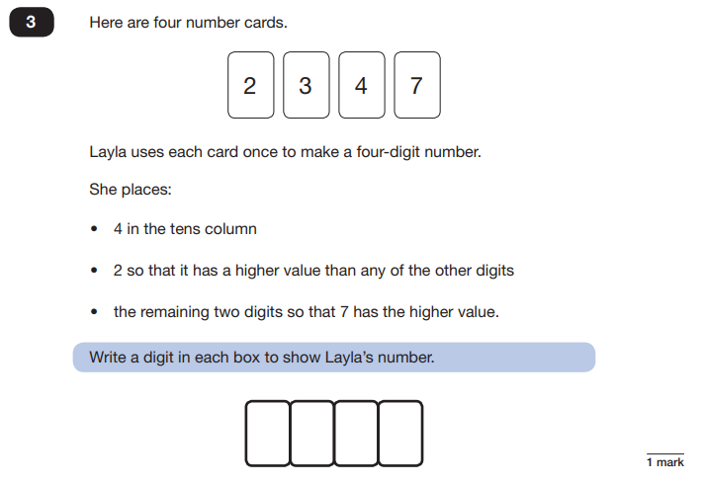

Key Stage 2: 2019 Paper 2 Reasoning
1.
